Qwiklabs Assessment: Automatically Generate a PDF and send it by Email

**Introduction**

You work for a company that sells second hand cars. Management wants to get a summary of the amounts of vehicles that have been sold at the end of every month. The company already has a web service which serves sales data at the end of every month but management wants an email to be sent out with an attached PDF so that data is more easily readable.

**What you’ll do**

* Write a script that summarizes and processes sales data into different categories
* Generate a PDF using Python
* Automatically send a PDF by email

You'll have 90 minutes to complete this lab.

linux-instance external IP address



content\_copy

username



content\_copy

password



content\_copy

[file\_download](https://googlecoursera.qwiklabs.com/lab_instances/download_pem/15763234" \t "_blank)

[Download PEM](https://googlecoursera.qwiklabs.com/lab_instances/download_pem/15763234" \t "_blank)

[file\_download](https://googlecoursera.qwiklabs.com/lab_instances/download_ppk/15763234" \t "_blank)

[Download PPK](https://googlecoursera.qwiklabs.com/lab_instances/download_ppk/15763234" \t "_blank)

# **Automatically Generate a PDF and send it by Email**

## Introduction

You work for a company that sells second hand cars. Management wants to get a summary of the amounts of vehicles that have been sold at the end of every month. The company already has a web service which serves sales data at the end of every month but management wants an email to be sent out with an attached PDF so that data is more easily readable.

### **What you'll do**

* Write a script that summarizes and processes sales data into different categories
* Generate a PDF using Python
* Automatically send a PDF by email

You'll have 90 minutes to complete this lab.

### **Start the lab**

You'll need to start the lab before you can access the materials in the virtual machine OS. To do this, click the green “Start Lab” button at the top of the screen.

**Note:** For this lab you are going to access the **Linux VM** through your **local SSH Client**, and not use the **Google Console** (**Open GCP Console** button is not available for this lab).

Start Lab

After you click the “Start Lab” button, you will see all the SSH connection details on the left-hand side of your screen. You should have a screen that looks like this:

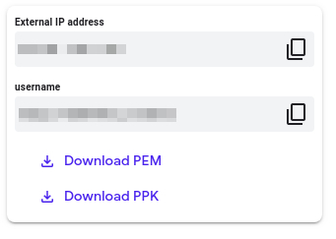

## Accessing the virtual machine

Please find one of the three relevant options below based on your device's operating system.

**Note:** Working with Qwiklabs may be similar to the work you'd perform as an **IT Support Specialist**; you'll be interfacing with a cutting-edge technology that requires multiple steps to access, and perhaps healthy doses of patience and persistence(!). You'll also be using **SSH** to enter the labs -- a critical skill in IT Support that you’ll be able to practice through the labs.

### **Option 1: Windows Users: Connecting to your VM**

In this section, you will use the PuTTY Secure Shell (SSH) client and your VM’s External IP address to connect.

**Download your PPK key file**

You can download the VM’s private key file in the PuTTY-compatible **PPK** format from the Qwiklabs Start Lab page. Click on **Download PPK**.

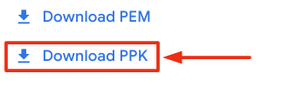

**Connect to your VM using SSH and PuTTY**

1. You can download Putty from [here](https://the.earth.li/~sgtatham/putty/latest/w64/putty.exe)
2. In the **Host Name (or IP address)** box, enter username@external\_ip\_address.

**Note:** Replace **username** and **external\_ip\_address** with values provided in the lab.



1. In the **Category** list, expand **SSH**.
2. Click **Auth** (don’t expand it).
3. In the **Private key file for authentication** box, browse to the PPK file that you downloaded and double-click it.
4. Click on the **Open** button.

**Note:** PPK file is to be imported into PuTTY tool using the Browse option available in it. It should not be opened directly but only to be used in PuTTY.



1. Click **Yes** when prompted to allow a first connection to this remote SSH server. Because you are using a key pair for authentication, you will not be prompted for a password.

**Common issues**

If PuTTY fails to connect to your Linux VM, verify that:

* You entered **<username>**@**<external ip address>** in PuTTY.
* You downloaded the fresh new PPK file for this lab from Qwiklabs.
* You are using the downloaded PPK file in PuTTY.

### **Option 2: OSX and Linux users: Connecting to your VM via SSH**

**Download your VM’s private key file.**

You can download the private key file in PEM format from the Qwiklabs Start Lab page. Click on **Download PEM**.

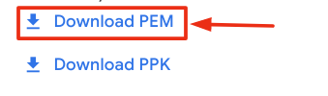

**Connect to the VM using the local Terminal application**

A **terminal** is a program which provides a **text-based interface for typing commands**. Here you will use your terminal as an SSH client to connect with lab provided Linux VM.

1. Open the Terminal application.
   * To open the terminal in Linux use the shortcut key **Ctrl+Alt+t**.
   * To open terminal in **Mac** (OSX) enter **cmd + space** and search for **terminal**.
2. Enter the following commands.

**Note:** Substitute the **path/filename for the PEM** file you downloaded, **username** and **External IP Address**.

You will most likely find the PEM file in **Downloads**. If you have not changed the download settings of your system, then the path of the PEM key will be **~/Downloads/qwikLABS-XXXXX.pem**

chmod 600 ~/Downloads/qwikLABS-XXXXX.pem

ssh -i ~/Downloads/qwikLABS-XXXXX.pem username@External Ip Address

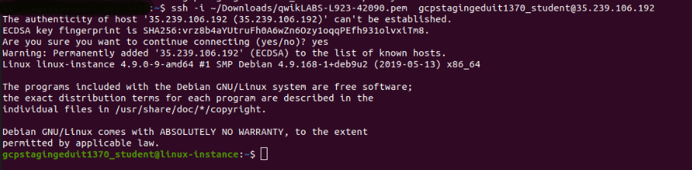

### **Option 3: Chrome OS users: Connecting to your VM via SSH**

**Note:** Make sure you are not in **Incognito/Private mode** while launching the application.

**Download your VM’s private key file.**

You can download the private key file in PEM format from the Qwiklabs Start Lab page. Click on **Download PEM**.



**Connect to your VM**

1. Add Secure Shell from [here](https://chrome.google.com/webstore/detail/secure-shell-app/pnhechapfaindjhompbnflcldabbghjo) to your Chrome browser.
2. Open the Secure Shell app and click on **[New Connection]**.

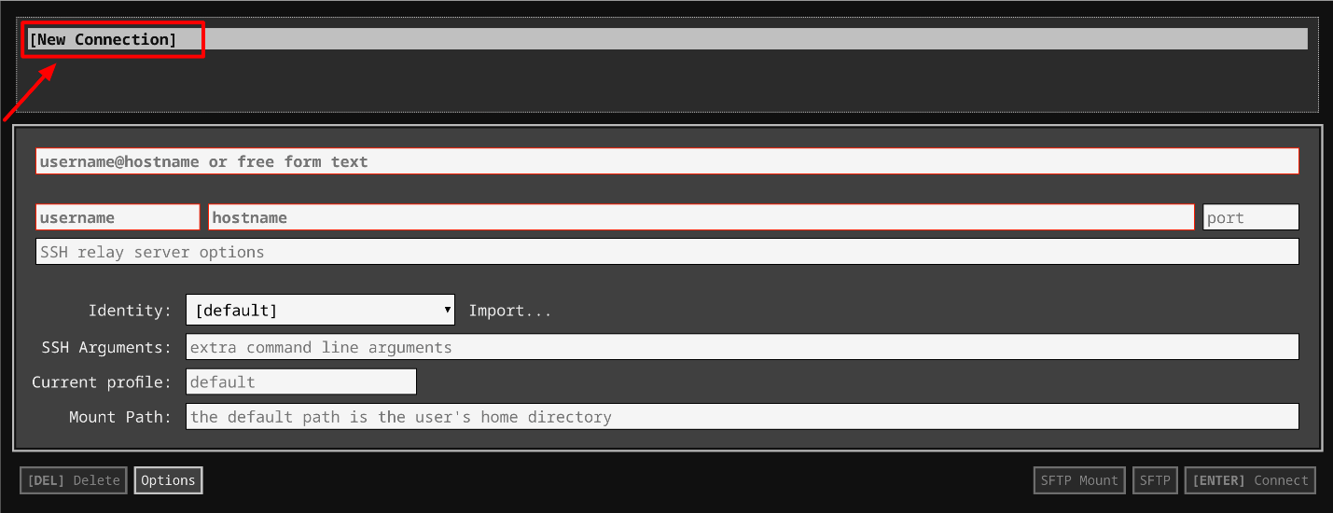

1. In the **username** section, enter the username given in the Connection Details Panel of the lab. And for the **hostname** section, enter the external IP of your VM instance that is mentioned in the Connection Details Panel of the lab.

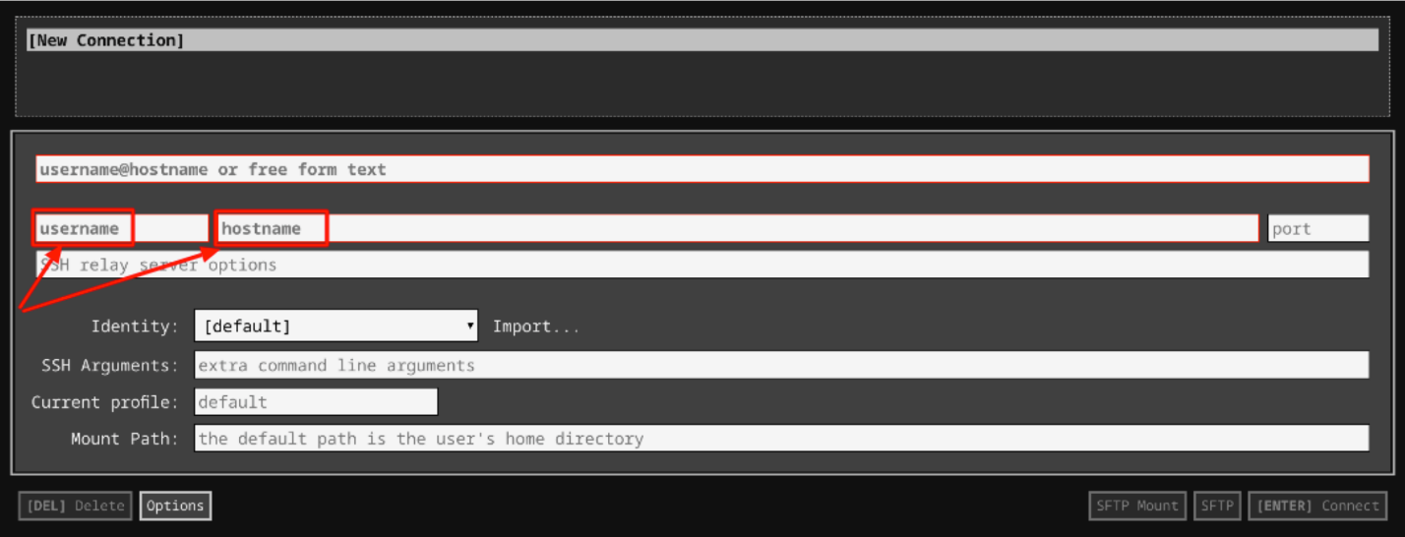

1. In the **Identity** section, import the downloaded PEM key by clicking on the **Import…** button beside the field. Choose your PEM key and click on the **OPEN** button.

**Note:** If the key is still not available after importing it, refresh the application, and select it from the **Identity** drop-down menu.

1. Once your key is uploaded, click on the **[ENTER] Connect** button below.

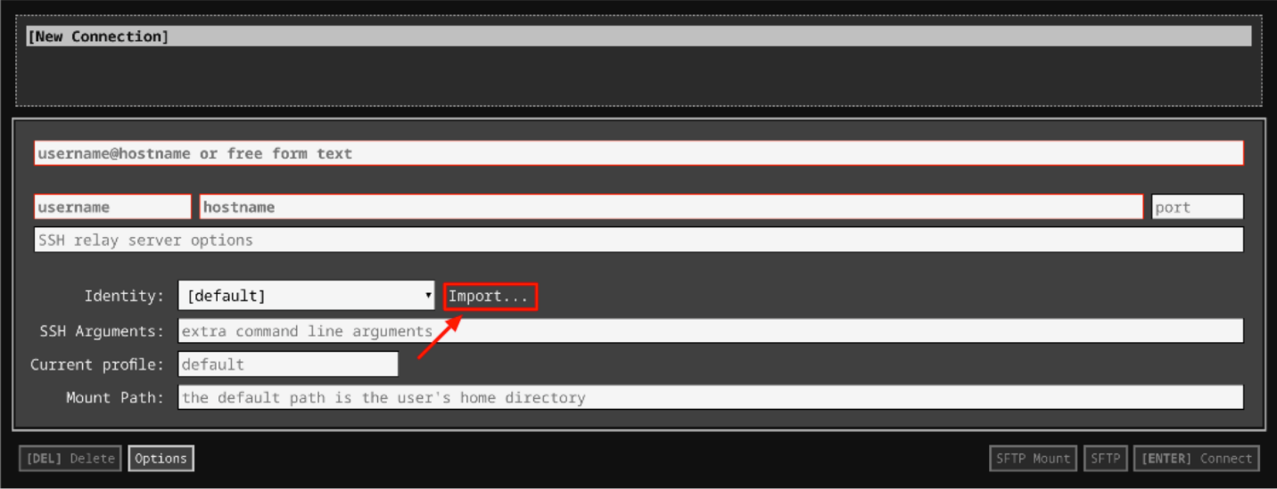

1. For any prompts, type **yes** to continue.
2. You have now successfully connected to your Linux VM.

You're now ready to continue with the lab!

## Sample report

In this section, you will be creating a PDF report named "**A Complete Inventory of My Fruit**". The script to generate this report and send it by email is already pre-done. You can have a look at the script in the scripts/ directory.

ls ~/scripts

Output:



In the scripts/ directory, you will find reports.py and emails.py files. These files are used to **generate PDF files** and **send emails** respectively.

Take a look at these files using cat command.

cat ~/scripts/reports.py

Output:

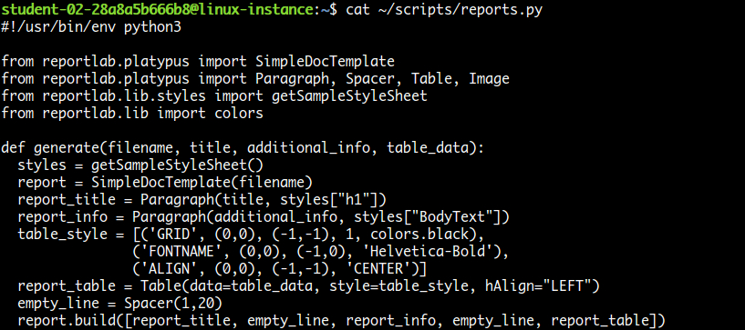

cat ~/scripts/emails.py

Output:

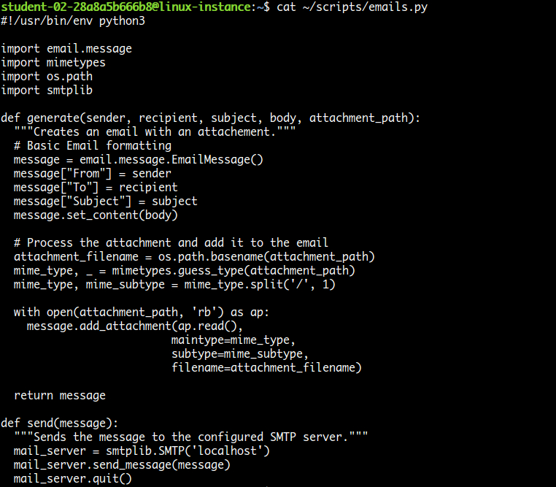

Now, take a look at example.py, which uses these two modules **reports** and **emails** to create a report and then send it by email.

cat ~/scripts/example.py

Grant executable permission to the example.py script.

sudo chmod o+wx ~/scripts/example.py

Run the example.py script, which will generate mail to you.

./scripts/example.py

A mail should now be successfully sent.

Copy the external IP address of your instance from the Connection Details Panel on the left side and open a new web browser tab and enter the IP address. The Roundcube Webmail login page appears.

Here, you'll need a login to **roundcube** using the username and password mentioned in the Connection Details Panel on the left hand side, followed by clicking **Login**.

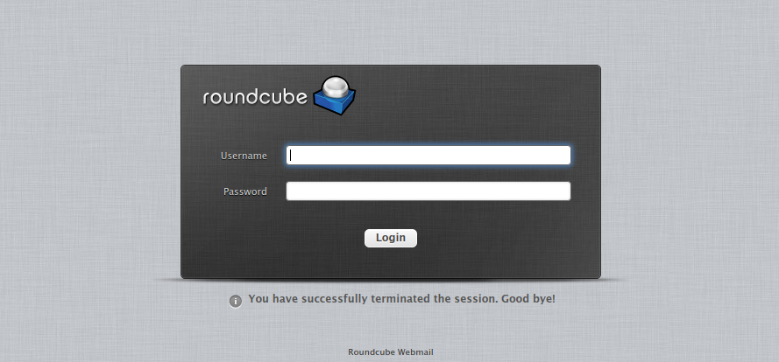

Now you should be able to see your inbox, with one unread email. Open the mail by double clicking on it. There should be a report in PDF format attached to the mail. View the report by opening it.

Output:

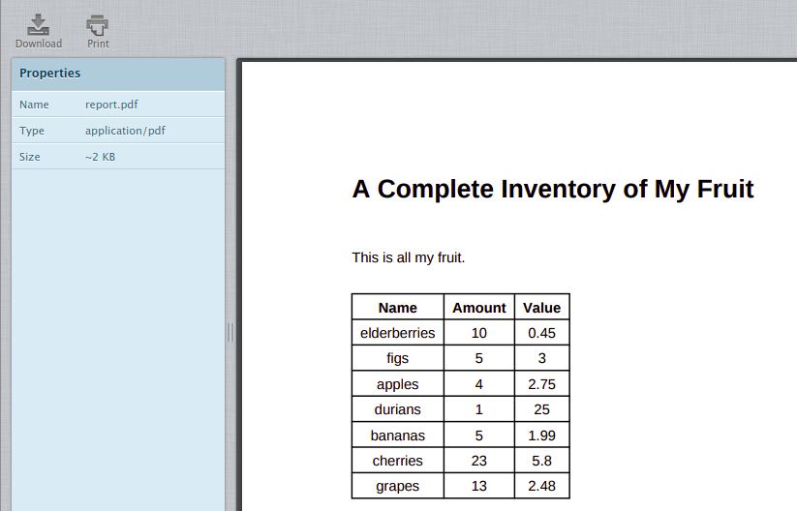

### **Generate report**

Now, let's make a couple of changes in the example.py file to add a new fruit and change the sender followed by granting editor permission. Open example.py file using the following command:

nano ~/scripts/example.py

And update the following variables:

|  |  |
| --- | --- |
| **variable\_name** | **value** |
| sender | Replace **sender@example.com** with **automation@example.com** |
| table\_data | Add another entry into the list: ['kiwi', 4, 0.49] |

The file should now look similar to:

#!/usr/bin/env python3

import emails

import os

import reports

table\_data=[

['Name', 'Amount', 'Value'],

['elderberries', 10, 0.45],

['figs', 5, 3],

['apples', 4, 2.75],

['durians', 1, 25],

['bananas', 5, 1.99],

['cherries', 23, 5.80],

['grapes', 13, 2.48],

['kiwi', 4, 0.49]]

reports.generate("/tmp/report.pdf", "A Complete Inventory of My Fruit", "This is all my fruit.", table\_data)

sender = "automation@example.com"

receiver = "{}@example.com".format(os.environ.get('USER'))

subject = "List of Fruits"

body = "Hi\n\nI'm sending an attachment with all my fruit."

message = emails.generate(sender, receiver, subject, body, "/tmp/report.pdf")

emails.send(message)

Once you've made the changes in the example.py script, save the file by typing **Ctrl-o**, **Enter** key and **Ctrl-x**.

Now execute the example script again.

./scripts/example.py

Now, check the webmail for any new mail. You can click on the **Refresh** button to refresh your inbox.

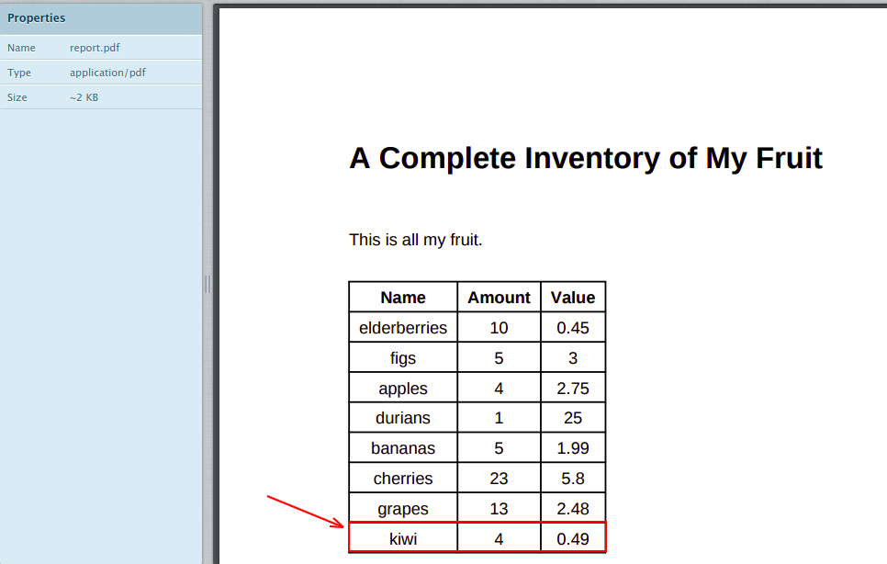

Click Check my progress to verify the objective.

Generate sample report

Check my progress

## Sales summary

In this section, let's view the summary of last month's sales for all the models offered by the company. This data is in a JSON file named car\_sales.json. Let's have a look at it.

cat car\_sales.json

Output:

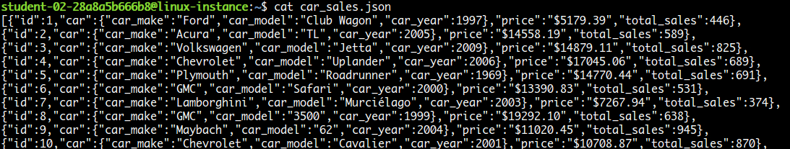

To simplify the JSON structure, here is an example of one of the JSON objects among the list.

{

"id": 47,

"car": {

"car\_make": "Lamborghini",

"car\_model": "Murciélago",

"car\_year": 2002

},

"price": "$13724.05",

"total\_sales": 149

}

Here id, car, price and total\_sales are the field names (key).

The script cars.py already contains part of the work, but learners need to complete the task by writing the remaining pieces. The script already calculates the car model with the most revenue (price \* total\_sales) in the process\_data method. Learners need to add the following:

1. Calculate the car model which had the most sales by completing the process\_data method, and then appending a formatted string to the summary list in the below format:

* "The {car model} had the most sales: {total sales}"

1. Calculate the most popular car\_year across all car make/models (in other words, find the total count of cars with the car\_year equal to 2005, equal to 2006, etc. and then figure out the most popular year) by completing the process\_data method, and append a formatted string to the summary list in the below format:

* "The most popular year was {year} with {total sales in that year} sales."

### **The challenge**

Here, you are going to update the script cars.py. You will be using the above JSON data to process information. A part of the script is already done for you, where it calculates the car model with the most revenue (price \* total\_sales). You should now fulfil the following objectives with the script:

1. Calculate the car model which had the most sales.

a. Call format\_car method for the car model.

1. Calculate the most popular car\_year across all car make/models.

**Hint:** Find the total count of cars with the car\_year equal to 2005, equal to 2006, etc. and then figure out the most popular year.

Grant required permissions to the file cars.py and open it using nano editor.

sudo chmod o+wx ~/scripts/cars.py

nano ~/scripts/cars.py

The code is well commented including the TODO sections for you to understand and fulfill the objectives.

### **Generate PDF and send Email**

Once the data is collected, you will also need to further update the script to generate a PDF report and automatically send it through email.

To generate a PDF:

* Use the reports.generate() function within the main function.
* The report should be named as **cars.pdf**, and placed in the folder **/tmp/**.
* The PDF should contain:
  1. A summary paragraph which contains the most sales/most revenue/most popular year values worked out in the previous step.

**Note:** To add line breaks in the PDF, use: <br/> between the lines.

* + A table which contains all the information parsed from the JSON file, organised by id\_number. The car details should be combined into one column in the form <car\_make> <car\_model> (<car\_year>).

**Note:** You can use the **cars\_dict\_to\_table** function for the above task.

Example:

|  |  |  |  |
| --- | --- | --- | --- |
| **ID** | **Car** | **Price** | **Total Sales** |
| 47 | Acura TL (2007) | €14459,15 | 1192 |
| 73 | Porsche 911 (2010) | €6057,74 | 882 |
| 85 | Mercury Sable (2005) | €45660,46 | 874 |

To send the PDF through email:

Once the PDF is generated, you need to send the email, using the emails.generate() and emails.send() methods.

Use the following details to pass the parameters to emails.generate():

* **From:** automation@example.com
* **To:** <user>@example.com
* **Subject line**: Sales summary for last month
* **E-mail Body:** The same summary from the PDF, but using \n between the lines
* **Attachment:** Attach the PDF path i.e. generated in the previous step

Once you have completed editing cars.py script, save the file by typing **Ctrl-o**, **Enter** key, and **Ctrl-x**.

Run the cars.py script, which will generate mail to their user.

./cars.py

Now, check the webmail for any new mail. You can click on the **Refresh** button to refresh your inbox.

Output:

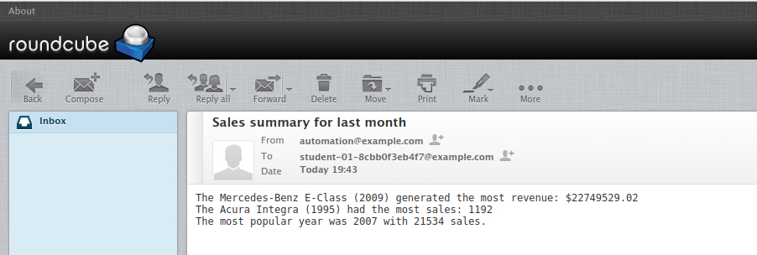

Open cars.pdf that's located on the right most side.

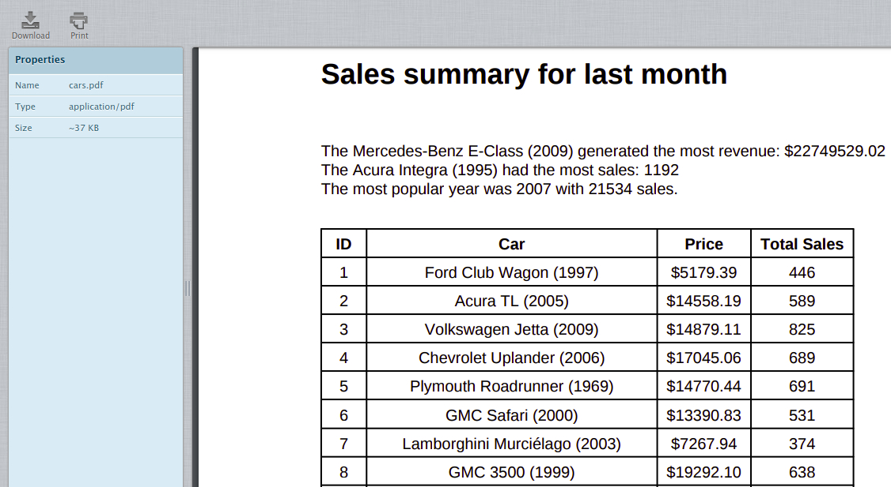

Click Check my progress to verify the objective.

Challenge: Sales summary

Check my progress

## Optional challenge

As **optional** challenges, you could try some of the following functionalities:

1. Sort the list of cars in the PDF by total sales.
2. Create a pie chart for the total sales of each car made.
3. Create a bar chart showing total sales for the top 10 best selling vehicles using the [ReportLab Diagra library](https://www.reportlab.com/software/diagra/). Put the vehicle name on the X-axis and **total revenue** (remember, price \* total sales!) along the Y-axis.

## Congratulations!

Congrats! You've successfully written a Python script to automatically generate a PDF and send it through email.

## End your lab